CT4003 Assignment 2

### Angel Jayin, Phillip Turner, Jordan Oren, Subhan Naeem, Emdrei Prifti

Contents

Solving a Problem 3

Case Study 3

Requirements from initial Meetings 3

Preparation for the project 3

Informal Meeting Notes 4

Components 5

Humidity and temperature sensor 5

Ultrasonic distance sensor 5

Water sensor 5

L.E.D bulb and Piezo speaker 6

Pseudo code 7

Execution of the project 8

Screenshots of the serial monitor 9

Testing 10

Test plan 11

Unseen problems 13

How we can improve the project 13

Members contribution 14

Personal Reflections 14

Angel Jayin 14

Phillip Turner 14

Jordan Oren 14

Subhan Naeem 15

YouTube Video 15

## Solving a Problem

For the purpose of this assignment our team was asked to come up with a project. To reflect the team ethos we decided to do an innovative project which would be solving an existing problem and also has room for expansion in the future. Starting to gather ideas for the project, we decided to solve a problem that a colleague is facing. The problem is briefly explained in the case study.

## Case Study

Luke is a geography student at the University of Gloucestershire. He wants to see the environment factors of a precise location and record it physically into a logbook. The data he records in the logbook will be used as supporting evidence for his course dissertation. Luke does not use public data from professional organizations such as the MET office as they are very generic to an area and does not give accurate data of a precise location. He has bought temperature sensors in the past from high street retailers and was disappointed with the practicality as it was damaged by trespassers of his property including pets.

## Requirements from initial Meetings

Although each of us had different views on how to tackle the situation we concluded that we needed to write a program that performed the following.

* Displays the humidity and temperature of air surrounding the sensor.
* Computes if there is water content in soil to determine if the soil was exposed to rain or mist lately.
* Deters intruders or trespassers who are within certain proximity of the weather station from approaching the station further.

Furthermore to comply with programming ethics we also decided to make the source codes as efficient and as easy to develop as possible. This was through the use of extensive commenting and logical code placement.

## Preparation for the project

Having clearly understood the aim of the project our team prepared for the project by ordering the components for the project. The shipment time of the components was wisely utilized by collecting libraries and data sheets for the components. We have also used informal techniques such as stepwise refinement using pseudo code to make the programming process easier and professional later on.

## Informal Meeting Notes

**5th meeting**

* We need to refine the code to a good standard so that it is easy to develop
* We need to test the final code again
* We need to investigate further into how to improve the existing project

**4th meeting**

* We need to demonstrate the final program and test it
* We need to document a report concerning all aspects of the project
* We need to make a video which demonstrates the project in action

**3rd meeting**

* We need to combine all the codes and create a draft standard working program
* We need to review what we are doing relates to the actual requirement specification.
* We need to find ways to make the project innovative

**2nd meeting**

* We need to add SVN plugin to the eclipse versions at home and university.
* We need to create a Github account and link it to the tutors repository
* We need to familiarize with Github and eclipse
* We need to test each components with codes that are relevant to the final project

**1st meeting**

* We need to get ideas for project
* We need to order components for the build
* We need to collect libraries for the components used
* We need to evaluate if this project is viable

## Components

For the purpose of this project we have used the Arduino Uno microcontroller. The components that we used for the project were as follows.

* Humidity and temperature sensor
* Ultrasonic distance sensor
* Water sensor
* L.E.D bulb
* Piezo speaker

We have also used low resistance wires to connect the components with the Arduino microcontroller. A USB cable was used to transfer the codes to the microcontroller from the IDE and to power the microcontroller at the same time.

### Humidity and temperature sensor

The humidity and temperature sensor used in the project was used to provide live feed on the local temperature and humidity. The pin used for this component was digital and also used a library to convert the raw readings to a standard unit such as degree Celsius.

### Ultrasonic distance sensor

The ultrasonic distance sensor was used to compute the distance between an intruder and the microcontroller. This data was not only being displayed on the serial monitor but was also used to perform outputs on digital pin 13. The ultrasonic distance sensor was used in conjunction with if else statements to perform different outputs at different proximity of the intruder from the station. The ultrasonic distance sensor also used a library and a digital pin to perform its purpose. The sensor worked by triggering a pulse of wave and receiving it back to determine the distance between it and the intruder, using the link Speed = distance/time.

### Water sensor

The water sensor in this project was used to know the moisture content of soil when probed into. The water sensor used an analogue pin as opposed to all the other components of this project which used digital pins. The water sensor did not require a library. This sensor worked on the principles of electric conductivity as readings from this sensor changed when the moisture content in the soil changed. Moisture in the soil is determined by the level of water which is electrically conductive in nature, thus changing the values read by the senor sensing conductivity of the material probed into.

### L.E.D bulb and Piezo speaker

The L.E.D bulb and piezo speakers were used as outputs to deter intruders from the stations proximity. These output devices were triggered by the ultrasonic distance sensors upon detecting objects at a certain distance.

## Pseudo code

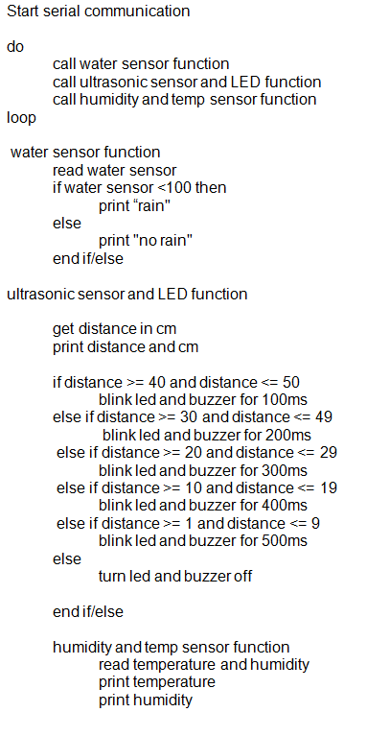

## Execution of the project

With a lot of troubleshooting and problem solving we have created a fully functional environment sensor that is purpose fit for the client. Each of the components was tested first using simple commands to ensure they were operational. Eventually the components were used in conjunction with each other using “if else” statements. We have also used serial communication to update us on the readings the sensors took, enabling us to compare it to the outputs from the Arduino and get real time feedback of the executed code. This was a good practice as it highlighted unexpected errors in the code and also reinforced our understanding. E.g. Difference between “if” “if else”and “while” statements.

We also ensured maximum compatibility of the code with different Arduino models by using statements that were relevant to them. For example we wrote the highlighted code on the program to ensure that the program is compatible with the Arduino duo.

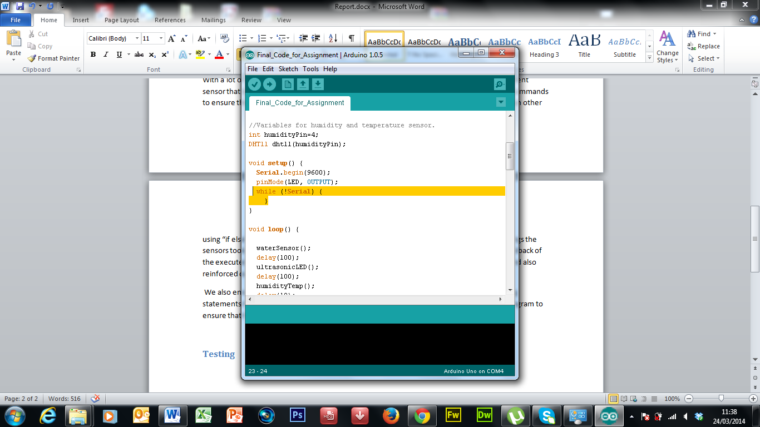

## Screenshots of the serial monitor

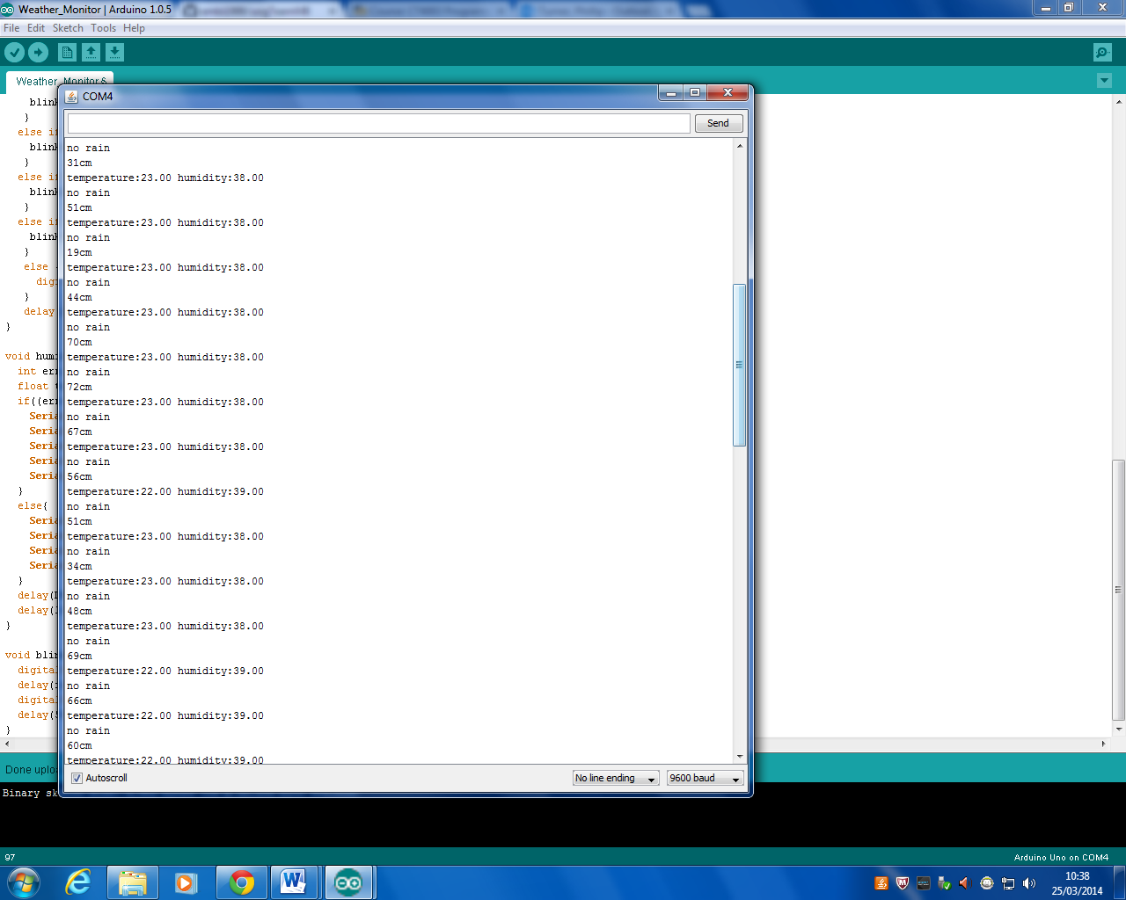

In this serial monitor, we can see that the information is being updated several times to show real time feedback. NOTE: this is how the user would see the data.

This line indicates whether there has been rain on a probed soil. This information is generated by the water sensor which we have adapted to be used a rain sensor. If there is water in the soil, it would suggest that there has been a rain and thus will display a message saying “rain”.

The temperature and humidity is being displayed in a single line. Decimal points indicate the level of precision used.

This line indicates the distance of the intruder from the ultrasonic sensor. This information is also used to trigger the deterring outputs such as the speaker and the led.

## Testing

We were continuously testing the code as it was developed to make sure we were not faced with lots of bugs at the end. This was achieved by white box testing methods such as stepping through the code with break points.

Black box testing of the final product was done in two phases. The first one comparing how the expected result and actual result related and the second one using the product as the client would use it.

Testing the product in the clients view point, we compared the results such as the temperature readings from the Arduino to a reliable standalone temperature station. The results had an uncertainty of +/- 2%, which is acceptable for a domestic and noncommercial project.

### Test plan

|  |  |  |  |  |  |  |
| --- | --- | --- | --- | --- | --- | --- |
| **Sensor** | **Type** | **Test Case Description** | **Expected outcome** | **Actual outcome** | **Result** | **Amendments** |
| **Water sensor** | Positive test case | Put system in wet and dry soil | display "rain" message | The system displayed “rain” message | PASS | n/a |
| **Water sensor** | Negative test case | Put system in dry soil | Display "no rain” message | The system displayed “no rain” message | PASS | n/a |
| **Temp sensor** | Positive test case | Put system near heat | Display the temperature | The system displayed the correct temperature | PASS | n/a |
| **Temp sensor** | Negative test case | Put system near cold | Display the temperature | The system displayed the correct temperature | PASS | n/a |
| **Humidity sensor** | Positive test case | Put the system in damp room | Display the level of humidity | The system displayed the correct level of humidity | PASS | n/a |
| **Humidity sensor** | Negative test case | Put the system in a dry room | Display the level of humidity | The system displayed the correct level of humidity | PASS | n/a |
| **Ultrasound sensor** | Positive test case | Place system near animal | Noise to scare away animal | The system scared away the animal | PASS | n/a |
| **Ultrasound sensor** | Negative test case | Place system away from animal | No noise | The system did not scare away animal | PASS | n/a |
| **Water sensor** | Boundary value | Show if the rain makes contact with the sensor | Display either "Rain" or "No rain" message | Correct message displayed | PASS | n/a |
| **Temp sensor** | Boundary value | 10 degrees above or below room temperature | Display a temperature within the boundaries | Correct temperature displayed | PASS | n/a |
| **Temp sensor** | Boundary value | 11+ Degree's above room temp or 11+ Degree's below room temp | Fails to display temperature | Failed to display temperature | PASS | n/a |

|  |  |  |  |  |  |  |
| --- | --- | --- | --- | --- | --- | --- |
| **Humidity sensor** | Boundary value | 0-50℃ | Between these value's display the level of humidity | Correct level of humidity displayed | PASS | n/a |
| **Humidity sensor** | Boundary value | Above 50 or below 0℃ | Error message (Will not display the level of humidity) | Error message displayed | PASS | n/a |
| **Ultrasound sensor** | Boundary value | Between 0 and 50cm | Display the distance of animal/ LED on/ makes noise | Correct distance displayed and correct output | PASS | n/a |
| **Ultrasound sensor** | Boundary value | Over 50cm | Will not display anything as too far | Did not display anything | PASS | n/a |

## Unseen problems

As our project incorporated many hardware components and the Arduino Uno only providing limited power pins, we found it hard to incorporate other communication techniques such as LCD displays. However this could easily be resolved by using an Arduino with higher technical specification such as the Arduino mega.

All the team members having different libraries and working on dated versions of the source code seemed problematic as more time had to be spent to redefine the variables and to incorporate functions to the existing code.

The testing process took much time than what we expected as there was a lot of ambiguity on how to rectify a fault. This was due to the various factors through which an intended result could not be achieved. Some of these factors included wrong source codes, physical breakdown of components, incompatible libraries and wiring errors

## How we can improve the project

We could have expanded the project further by adding more inputs and outputs such as buttons and LCD monitors to make the usage much more interactive and engaging. However lack of the hardware specification we possess now limits us from doing it for this module of study.

So as to make changes to the task performed by the Arduino, a graphical user interface could be designed and implemented which will enable the client to amend tasks performed by the Arduino, without the knowledge of programing.

Marketing and distribution of this product to the general public is not feasible due to the low demand and unprofessional aesthetic appeal. However unprofessional aesthetics of this product could be solved by providing a bespoke case using manufacturing processes such as injection molding.

The intruder deterring system could be further developed to produce ultrasonic sound of a certain frequency when not in use so that it repels mosquitos and other bugs which might not be detected by the ultrasonic sensor.

## Members contribution

|  |  |
| --- | --- |
| **Strand of the project** | **Members involved** |
| Designing | Philip, Angel and Jordan |
| Implementation | Philip, Angel and Jordan |
| Testing | Philip, Angel and Jordan |
| Test case | Philip, Angel and Jordan |
| Documentation | Philip, Angel and Jordan |
| Overseeing the project | Philip, Angel and Jordan |
| Github administration | Philip, Angel and Jordan |

## Personal Reflections

### Angel Jayin

I have thoroughly enjoyed doing the project and would like to develop it furthermore by assigning more tasks to be executed by the Arduino. The project has been a pleasure to complete and provided satisfaction as I personally like problem solving. I have learned how to enable communication between microcontrollers and external hardware to solve a problem. This would comply with my ethos of using technology to benefit mankind. This project lacking aesthetic appeal has sparked my interest in doing research on plastic case manufacturing methods such as injection molding.

Academics aside this project has provided me with intermediate skill to program domestic home automation systems which could be beneficial personally. I would not have been able to achieve these skills if I had not done this module of study. To increase my understanding of building robust program I have researched into black box testing and white box testing.

### Phillip Turner

With previous programming experience I didn’t find the programming aspect too challenging. What I did find challenging was helping come up with an idea for the project and thinking of the simplest way to implement this. The hardest thing I found was working as part of the team as everyone has their own opinions and ways to do things because I have never programmed as part of a group project before. But I did enjoy the group work as it is more like what a work situation would be like. Doing this assignment has improved my time management significantly for example other people rely on parts of the code you write so that has made sure I have completed my work on time.

### Jordan Oren

I have enjoyed working with Arduino throughout Semester Two. It has been practically enjoyable working with the many different sensors we included in our assignment. My main task in this assignment was to produce the test cases and to carry the test plan, although this was my main task each member actively took part in each task so therefore there was no confusion into what was happening during the assignment. I think that working with Arduino now for the whole of level 4 I am confident that I have a broad knowledge of how to work Arduino and some of its components. I am looking forward to be working with Arduino one again in the foreseeable future.

### Subhan Naeem

I thoroughly enjoyed working with various sensors and programming them with Arduino throughout semester two as it was something new to me and it was something of an intriguing task. During the course of the assignment, while other members of my group had different responsibilities, I was tasked with producing a test case and testing the various sensors to see how they worked. It was genuinely of importance as I have developed both analytical and interpersonal attributes.

## YouTube Video

Below is the link to the team YouTube video.

<http://youtu.be/VLejaDQ8Ao0>